Emeritus Professor Dr. Maxine M. Thompson, Horticulturist, Plant Explorer (1926 – 2021)
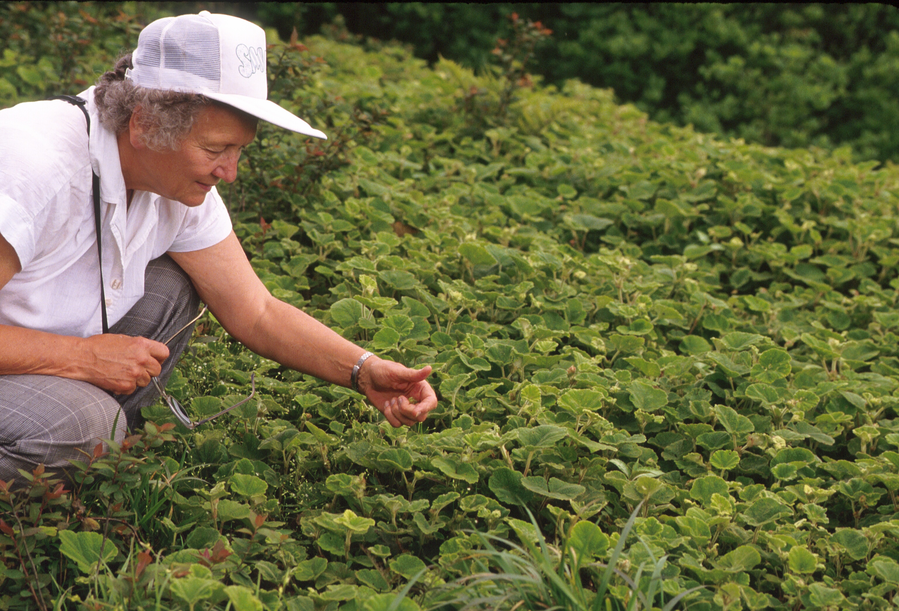
Dr. Maxine M. Thompson, world-renowned horticulturist and plant explorer passed away on 1 March 2021. Maxine was born on 3 November 1926, in Bloomington, Illinois. After a few years in Illinois and Minnesota, her family moved to Pasadena, California, where she grew up. She received an Associate of Arts degree from Pasadena Junior College in 1945, and a B.S. in Plant Science in 1948, M.S. in Horticulture (Pomology) in 1951, and Ph.D. in Genetics in 1960, all from the University of California- Davis. Her major professor was Dr. H. P. Olmo, the renowned grape breeder. While in graduate school, she married Harry S. Thompson, a student in the Veterinary College. They had two children, Michael and Laurie.
Dr. Maxine Thompson with low growing Rubus crassifolius T.T. Yu & L.T. Lu from Guizhou, China, in 1992.
From 1960 to 1964, Dr. Thompson took a position as a part-time Junior Specialist in the Viticulture Department at the University of California-Davis, while simultaneously caring for her young children as a single parent. In 1964, she accepted a position as Assistant Professor in Biology at Wisconsin State College-Oshkosh, where she taught General Botany, Cytology, and Genetics. In 1965, she moved to Corvallis, Oregon, where she had a series of temporary appointments in the Department of Botany and the Department of Horticulture. She was supervised by Dr. Quentin Zielinski, until his untimely passing. In 1969, she became Assistant Professor of Horticulture, the first woman to be appointed to a tenure track position in that department. Her major research activities involved fruit breeding and genetics of hazelnut and sweet cherry, and floral biology, pollination, fruit set, and cytological studies of fruit and nut species. Her teaching responsibilities included undergraduate classes in General Botany, and Fruit Systematics and graduate classes in Plant Genetics, Pollination, and Fruit set.
During her assignment at Oregon State University, Dr. Thompson was an excellent mentor to graduate students. She provided a friendly face, generous use of laboratory equipment, and helpful advice whenever students visited her fourth floor lab. When students had difficult times, she spoke up for those who had complexities of balancing a professional career while managing a young family.
Dr. Thompson was fascinated with wild and cultivated plant variation. This interest was born in her freshman General Botany class and expanded over many years to her final project, the breeding of blue honeysuckle, Lonicera caerulea L. Dr. Thompson was one of the founding scientists who lobbied for clonal genebanks in the U.S. National Plant Germplasm System (NPGS). Thanks in no small part to her efforts the first clonal genebank was dedicated in Corvallis, Oregon, in 1981. For many years, she participated on the Technical Committees for the National Clonal Germplasm Repository (NCGR) in Corvallis, and the Western Regional Plant Introduction Station, Pullman, Washington.
Her international genetic resources activities began with consultancies with the Food and Agriculture Organization (FAO) of the United Nations in 1982. She was hired to assess under-utilized fruits and nuts in six southeastern Asian countries (India, Nepal, Thailand, Malaysia, Indonesia, and the Philippines). She was assigned to a second consultancy that assessed fruit and nut genetic resources in Pakistan. Her objective was to recommend plant collection expeditions and design a plan for clonal genebanks in that country.
In 1986, she retired from her faculty position at Oregon State to embark on a series of U.S. Department of Agriculture sponsored international plant explorations for fruit and nut genetic resources. Her first trip, in 1987, was a six-month expedition to the mountains of Northern Pakistan, a region adjacent to Central Asia and rich in diversity of fruit and nut species. Next, she accompanied Dr. Calvin Sperling, USDA Plant Explorer, to Central Asia in Uzbekistan, Tajikistan, and Kazakhstan to collect apricots, cherries, peaches, plums, and apples. That same year she and Dr. Jim Ballington traveled to Ecuador to collect Rubus, Vaccinium, and other members of the Ericaceae with potential ornamental value. In 1992, she led an expedition to the southwest of the People’s Republic of China to collect blackberries and raspberries in Guizhou Province. She traveled to Kyrgyzstan, in 1994, to collect walnuts. In 1996, she returned to the People’s Republic of China, this time to the northeast. She led the expedition to collect small fruit germplasm in Jilin and Heilongjian Provinces with collaborators Chad Finn and Joseph Postman. Her final two expeditions occurred in 1998, to eastern Siberia, Russia, and in 2000, to Hokkaido, Japan, to obtain blue honeysuckle. Because of her plant collecting expeditions, Dr. Thompson donated 645 accessions (seeds and plants) to the U.S. National Plant Germplasm System (NPGS). In 1997, Dr. Thompson was honored with the Crop Science Society’s Frank M. Meyer Medal for Plant Genetic Resources, and, in 2000, with the American Pomological Society’s Wilder Medal.
The high caliper of Dr. Thompson’s science continues to be recognized. Fruit breeders and students of pomology study her Rubus cytogenetics manuscripts as seminal. Her manuscripts on the floral biology and non-dormancy of hazelnut are frequently cited. Her research into incompatibility in hazelnuts provided techniques for standard tests now used by several generations of nut breeders.
In the mid 1970’s, Dr. Thompson and plant pathologist colleague, Dr. H. Ronald Cameron, visited diseased orchards in southwest Washington. They noticed that among the nearly dead ‘DuChilly’ trees were pollinizer trees free of cankers. She made the first crosses with this pollinizer, ‘Gasaway’, in 1976. Recent releases from the OSU hazelnut breeding program carry a single dominant allele from ‘Gasaway’ that confers a high level of resistance to eastern filbert blight. From crosses made by Dr. Thompson, the Oregon State University hazelnut breeding program released four main crop cultivars (‘Willamette,’ ‘Lewis,’ ‘Clark’ and ‘Tonda Pacifica’), four pollinizers with high resistance to eastern filbert blight (VR 4-31, VR 11-27, VR 20-11, and VR 23-18), and one red-leafed ornamental (‘Rosita’). ‘Lewis’ was, for about a decade, the most widely planted cultivar in Oregon, until the release of ‘Yamhill’ and ‘Jefferson’. Growers have eagerly planted the resistant cultivars. Hazelnut orchards in Oregon increased from 29,000 acres in 2009, to more than 80,000 acres in 2021.
Since her final plant collecting expedition in 2000, Dr. Thompson embarked on the breeding of blue honeysuckle, called “Haskappu” in Hokkaido. Over the years, she obtained plant material from Russia and Japan. The Japanese subspecies Lonicera caerulea L. var. emphyllocalyx (Maxim.) Nakai proved to be the most useful parent because its flowering time suited the climate of the Willamette Valley. She planting thousands of seedlings, and selecting improved genotypes. Of these, she released and patented 10 cultivars. She continued this program on her own resources, supplemented with small research grants, but mainly out of her love and devotion to horticulture.
Her fierce independence and sharp scientific mind lead to a remarkable horticultural career. Her work spanned a score of years when our society’s concept of women in the workplace greatly changed. When she began, women, worked hard to be noticed professionally, and were offered lower salaries than were received by male counterparts. Those of us who have come along since then take for granted that our abilities are considered on equal par with other qualified individuals. The meritorious work of Dr. Thompson and others brought about this change. Dr. Maxine M. Thompson, geneticist, horticulturalist, professor, world explorer, and mentor, will continue to inspire generations of horticulturists yet to come.
Maxine requested no memorial service. Please remember her in your heart. Cards and condolences for the family can be sent c/o Michael Thompson, P.O. Box 12605, Salem, OR, 97309 and Laurie (Thompson) Catero, 36196 EW 1120, Seminole, Oklahoma, 74868. In lieu of flowers, donations can be made to the Horticulture Scholarship/Fellowship Fund within the Horticulture Department at Oregon State University. Donations can be made to “OSU Foundation” with “In Memory of Dr. Maxine M. Thompson” on the memo line and mailed to: OSU Foundation, 4238 SW Research Way, Corvallis, OR 97333, or the following link can be used for online contributions: https://securelb.imodules.com/s/359/foundation/index.aspx?sid=359&gid=34&pgid=1982&cid=3007&bledit=1&dids=889
Kim E. Hummer, USDA ARS National Clonal Germplasm Repository Corvallis, Oregon

