Updated in May 2020
Critical Point Dryer (CPD)
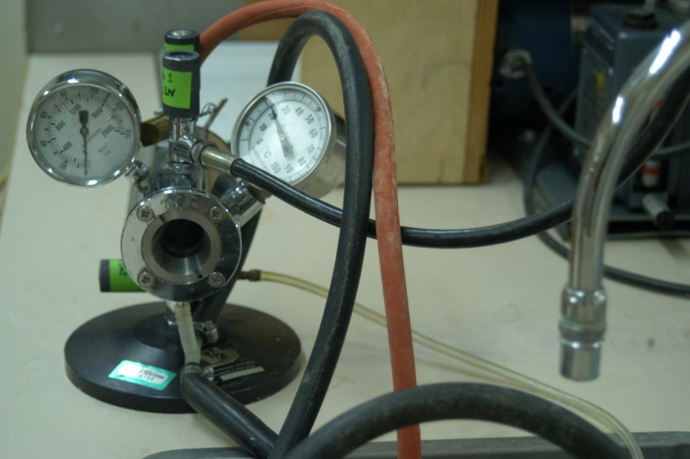
Make/Model: Polaron E3000 Series II
Applications: Preparing dry specimen for gold-coating and SEM observation.
INSTRUCTION

- Open CPD door by turning metal rod slid into the door handle.
- Place samples in metal sample holder (boat) which has immersed in pure acetone or ethanol (depending on the tissues) (using mesh basket to separate samples when necessary; covered with mesh stripe-mat), taking care to prevent the tissue samples from drying. Load the specimen boat and then screw the door back on (finger tight).
- Turn on cold water. Water should fill the jacket around the drying chamber. This cools the chamber to 15-20ºC. Hence, as CO₂ is let into the chamber it is a liquid, rather than a gas. Water should come out of the reddish rubber hose in the sink.
- Open the top black inlet knob 1 to let CO₂ into the chamber. The knob is on the top of the CPD near the window of the CPD
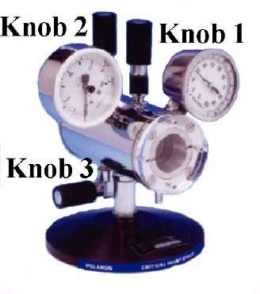
  - Make sure all 3 black knobs on the CPD are closed and the valve on the CO₂ tank is open.
  - There is liquid CO₂ in the chamber visible in the window on the back of the chamber. Look through the window (using the mirror if you want). The liquid CO₂ can be faint and difficult to see.

- Open the black drain knob 3 to let CO₂ out of the chamber. This knob is under the chamber.
  - The CO₂ level should stay high enough to cover the sample. This prevents damage to the sample.
- Turn off the cold water or leave it trickle.
- Flush the apparatus as outlined above (step 4 to 5) every half- or 1-hour for 30 sec or so, depending on the size of specimen, to allow specimens to infiltrate with CO2 and remove dehydrating fluid. Large specimens will require about 2-3 hr total time, while small specimens will be done in about 1 hr. Remember to leave the room door wide open to dissipate the CO2 gas that is being vented.
- After flushing, close the inlet valve of the tank and lower the liquid level to just below the top of the boat by venting off excess gas.
- Turn on hot water.
- Wait while the temperature and pressure rise.
  - This can take a few mins.
  - The temperature starts to rise ahead of the pressure.
- Once the critical point (31.5ºC and 1200 psi (lb/in²)) has been exceeded, shut off the hot tap water, and wait for 1-5 min depending on the size of specimen. Wait longer (up to 0.5-1 hour) for larger and/or thicker samples (hot tap water is required sometimes).
- Open the exhaust knob 2 on the top of the chamber to allow the gaseous CO₂ to escape slowly.
  - Be sure to let the CO₂ out gradually.
  - It should take 10-20 min for the pressure to reach zero.
- Open the door (sometimes it takes a while for the door to be opened), remove the sample and store the samples into sealed glass vials.
  - Be gentle with the sample as dry material can be brittle.
- Make sure the CO2 valve on cylinder is closed after finish.
Background (http://www.polaron-range.com/)
Critical Point Drying is an established method of dehydrating biological tissue prior to examination in the Scanning Electron Microscope (SEM). The “critical point” means where solid, liquid and vapor exist. Along the boundary between the liquid and vapor phases it is possible to choose a particular temperature and corresponding pressure, where liquid and vapor can co-exist and hence have the same density. This is the critical temperature and pressure, or critical point.

Critical point drying relies on this physical principle by bring samples to the critical of a suitable inert fluid. This inert fluid replaces water in the sample, and then vaporizes at its critical point without change of density and therefore without surface tension effects which distort morphology and ultrastructure. CO₂ is universally used today as the inert fluid. The critical point of CO₂ is at approximately 31.5ºC and 1200 psi (lb/in²) or 78 bar. Since liquid CO₂ is not sufficiently miscible with water, it is necessary to use an intermediate fluid (such as acetone, which is miscible with both water and liquid CO₂) during this process.

