Updated in May 2020

Dissecting Light Microscope
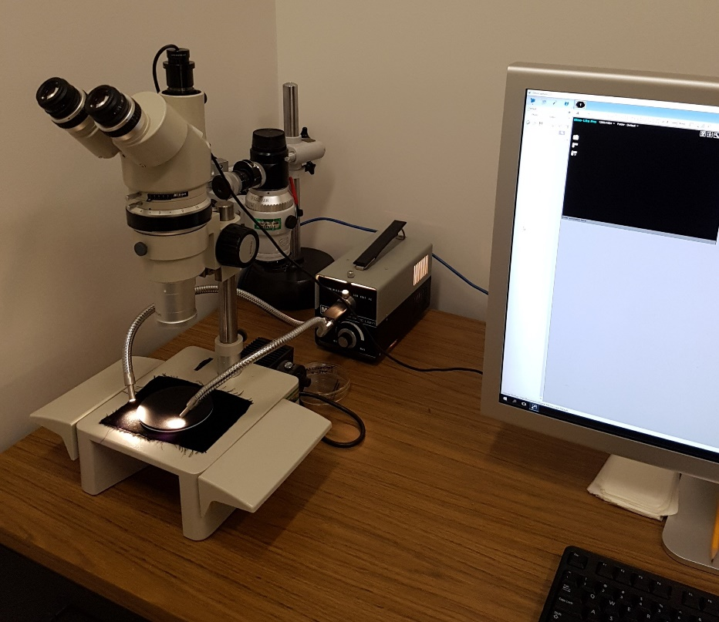
Make/Model:
- Nikon Stereoscope SMZ-10
Features:
- Episcopic and diascopic illuminations.
- Photomicrography with Dino-Eye USB digital color camera.
- Zoom objective lens: 0.66X-4X with a 0.53X reducing lens. Eyepiece magnification 10X.
Applications:
- Observing or taking photographs of specimen at the size of mm level that is neither good using conventional camera nor feasible using compound microscope.

