Updated in May 2020

Glass Knife Maker

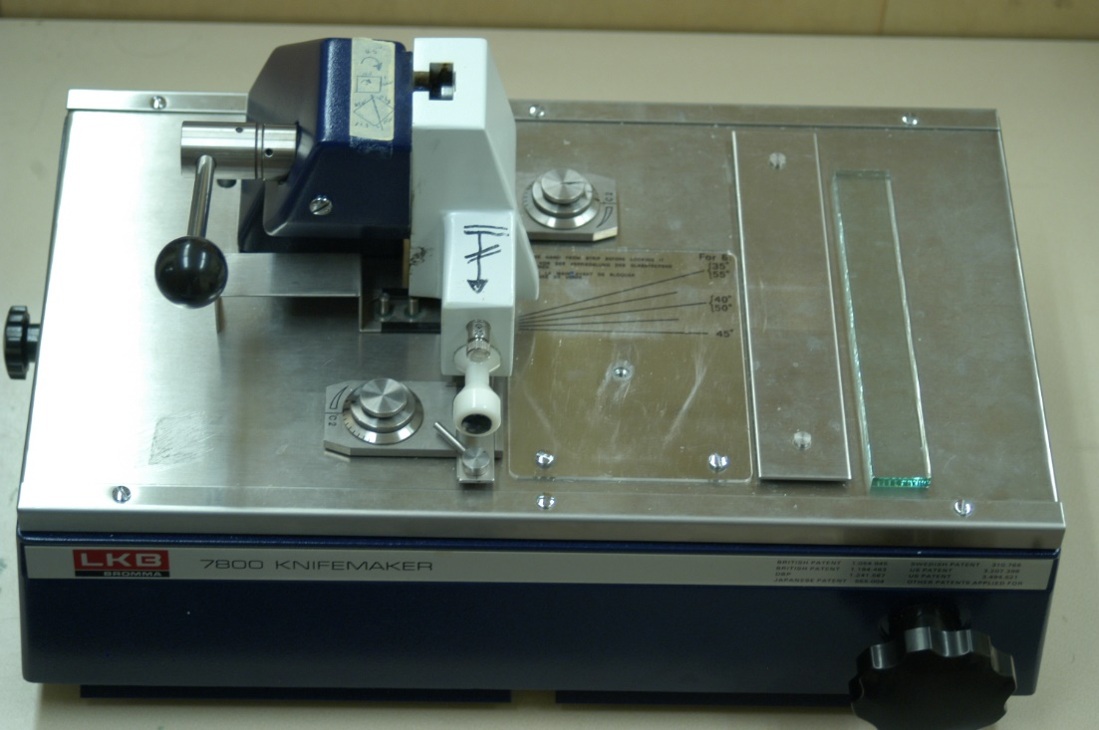
Make/Model:
- LKB 7800 Knifemaker.
Features:
- Choice of 25 mm and 38 mm glass strips.
- Flexible scoring selection.
Applications:
- Preparing glass knives for trimming or cutting thin/ultrathin sections of embedded TEM specimens.

INSTRUCTION
- Wash strip of glass with soapy water and/or alcohol to remove grease and dirt and dry on clean lint-free paper. For subsequent handling, hold the strip with a Kimwipe.
- If the glass strip is new (full sized), break it in half first. To cut strip exactly in half, remove fork and place strip over two pegs so that right end is at dot. The rippled (serrated) edge of the strip should be placed face down.

To make glass square:
- Align the glass bar so that the end is resting against the arresting stud and the side is against the angle setting plate. The angle setting plate should be set at 80° or 90°.
- Hold and lower clamping head onto strip with locking lever and tighten slightly to secure glass in a level position. Do not bounce the scorer on the glass.
- Select scoring position to parallel (marked with lines).
- Score glass by pulling scoring wheel across glass from back to front with continuous smooth stroke. Score should be distinct but not heavy enough to produce splinters of glass.
- Break glass by turning breaking knob clockwise slowly until glass begins to break.
- After glass breaks, turn breaking knob fully counterclockwise to initial position.
- Lift clamping head, assisting with your hand, push scoring shaft back in, and remove the glass square with fork.
To make glass knives:
- Turn the glass squire ¼ turn counterclockwise (see figure on the machine), put on top of breaking pins by inserting lower left edge between white guiding rings of front glass holder. Lower rear glass holder onto upper left edge of square by pushing in and turning counterclockwise to disengage the knob.
- Select scoring position marked with a diamond and 25 for 25mm glass.
- Lower the head, score, break and remove the glass as before.
- Scoring marks should be no more than 0.2 mm away from the upper left and lower right edges of center line. The upper edge of the left triangle and the lower edge of the right triangle are the knives. These edges should not be touched.
To check knives:
- View the glass knife with a dissecting scope. Good knife should have a narrow shoulder (<0.2mm), and as faint a pressure curve as possible. For either thick or thin sectioning, examine the knife edge directly to locate any edge imperfections, whiskers, contamination or fingerprints on the back of the knife. For thin sectioning, bounce light off the front edge of the knife. Any lines running parallel to the stress mark which sweeps from the left may result in knife marks. The best knives do not show this artifact. The sharpest edge is to the left generally, and the most durable surface is to the right (but left of the whiskers).
To put boats (troughs) on knives:
- Use a commercial plastic boat or use aluminum tape or electrical tape to make a boat. Seal with nail polish. Stick on double-sized tape and stored in a dust-free box. The knives are recommended to be used within a few days.

