Updated in May 2020
Gold Sputter Coater
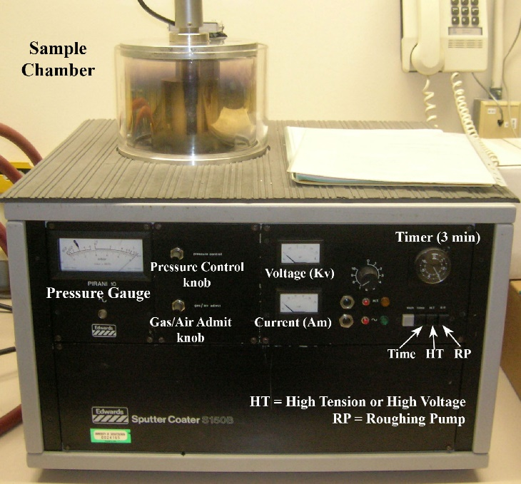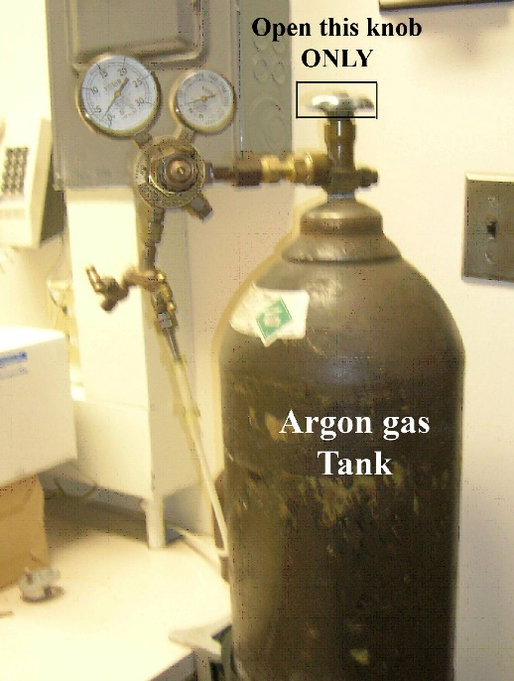
Model: Edwards S150B; Manufacturer: BOC Edwards, UK

INSTRUCTION
- To power on: push down two black buttons.
- Make sure that Gas/Air Admit and Pressure Control knobs are closed (finger tight).
- Open the chamber by holding the metal lid, and carefully set it on hold.
- The chamber should be at atmospheric pressure when not in use.
- Remove the inner (and outer cylindrical if any) wall of the chamber.
- Place the samples (which should be on metal stubs) onto the sample holder (a metal plate with 16 holes) using stub tweezers.
- Put sample holder inside the chamber and close the lid---MAKE SURE THE LID IS TIGHT AND NO LEAK.
- Press RP button (roughing pump) to create a vacuum in the chamber.
  - Wait for the pressure to drop to close to the black line on the pressure gauge at less than 1x10⁻¹atm. It will take about 5-10min.
- Open the main valve on the top of the argon cylinder (not the taped small valve!). Purge the chamber with argon by opening (counterclockwise) the Gas/Air Admit knob (the pressure meter reaches at 0 atm).
- Close the Gas/Air Admit knob and keep pumping until pressure is less than 1x10⁻¹atm again.
- Let argon gas into the chamber again by gradually turning Pressure Control knob until pressure rises to about 3x10⁻¹ mbar (the needle is aligned with the blue line on the glass window) and leave the knob at that position.
  - Set timer at 1 minute and HT scale reading number at 7-8: most times they are done already.
- Press both HT and Time buttons simultaneously. The indicator lamp lights. The purple glow discharge strikes in the chamber.
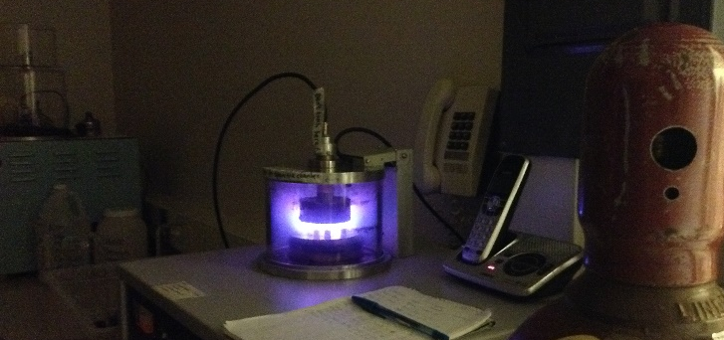
- Using the Pressure Control knob to keep voltage at about 1 kV. If they vary or the glow is flickering, adjust the Pressure Control to stabilize.
- When time is over (auto stop), close the Pressure Control knob. Then press HT, Time and RP buttons to release them.
- Let argon gas into the chamber to bring the pressure up to atmosphere by turning the Gas/Air Admit knob counterclockwise (widely). After about 20 sec, the chamber can be opened.
- Close the Gas / Air admit knob and close the valve on the top of the Argon tank.
- Remove the samples from the chamber, using tweezers. The samples are now ready for imaging in the SEM.
- Ensure the Pressure control and Gas / Air admit knobs are closed, but NOT TOO TIGHT.
- To power off: push down both red buttons.

