Image Analysis Workstation
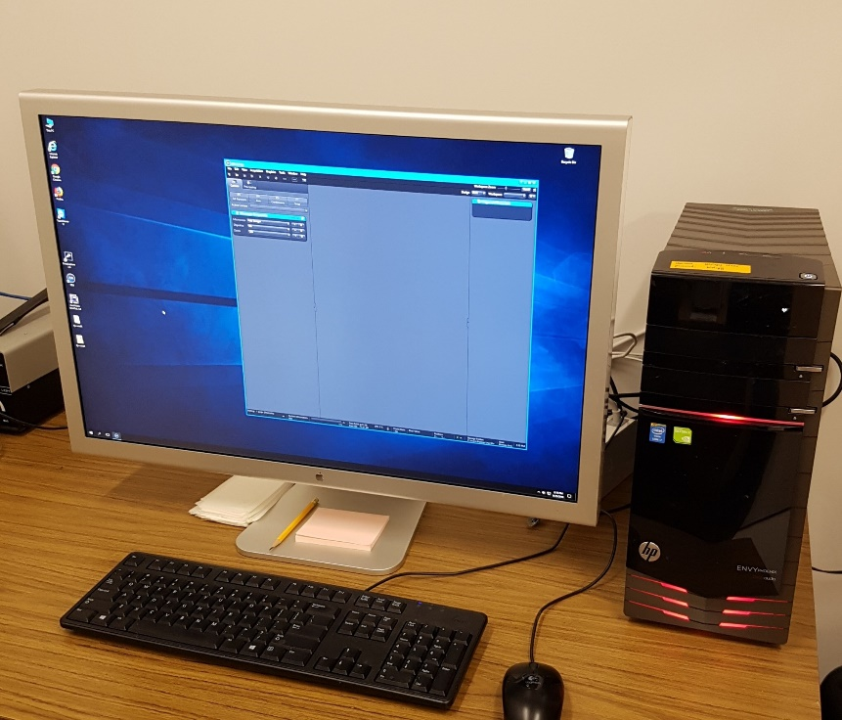
Specifications:
Hardware:
- 30″ Apple Cinema HD Display Monitor
- Windows 10 Education 64-Bit OS
- NVIDIA GeForce GTX 645 2GB Memory Graphics
- Intel® Core i7-4770K CPU
- 20 GB DDR3 RAM
- 128G SSD, 2 TB HD, Plus a Removable 2 TB USB3 Drive.
Imaging Software:
- Zeiss ZEN2 lite (blue)
- Zeiss AxioVision 4.7
- Zeiss LSM Image Browser
- FluoRender
- Fiji/ImageJ2
- DinoCapture 2.0
- Photoshop CS5
- CoralDraw 10
- Microsoft Office 2016
- Image Composite Editor

