Rotary microtomes
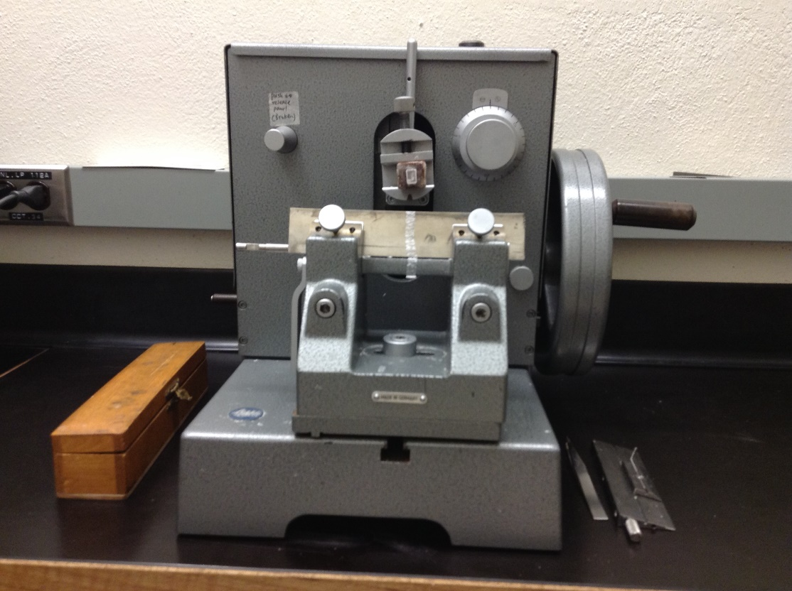
Make/Models: Leitz 1212

Features & applications: Section thickness: 1-25 µm. The microtome is an instrument favored for the cutting of paraffin sections. The compact design acknowledged stability and precision make it the perfect instrument of histology. The vertical object movement, the fixed knife, the convenient movement of the object sledge by means of a handwheel ensure uniform series of sections of medical and biological objects of good cutting properties. It is also extended to the cutting of thin sections of hard and difficult-to-cut biological and non-biological objects such as bone and fibres embedded in hard plastic media. Microtome knives: standard knife (L170mm, W42mm, T13mm); also useable with a Feather disposable blade holder.

