Updated in May 2020
Ultra-microtomes
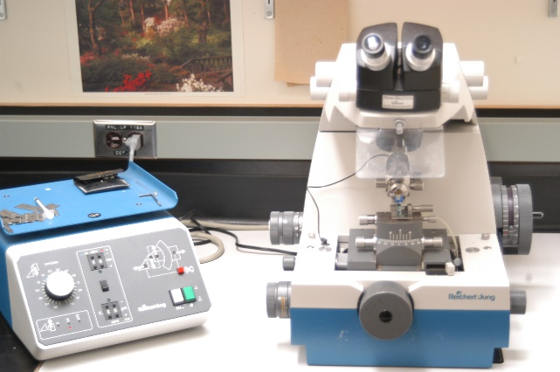 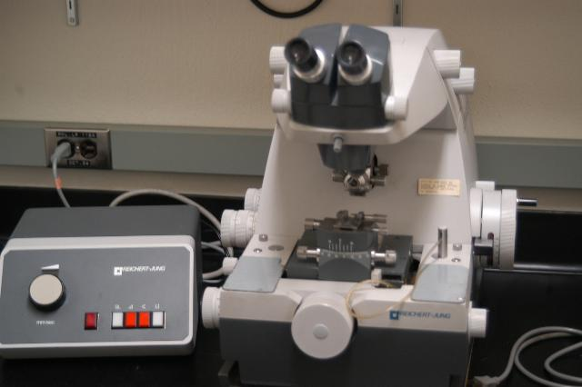
Make/Models: Ultracut & Ultracut E (1982 & 1990, Reichert-Jung, Vienna, Austria)
Applications: Section thickness 10-999 nm; Preparing semi-thin or ultra-thin sections for staining or TEM observation.

INSTRUCTION

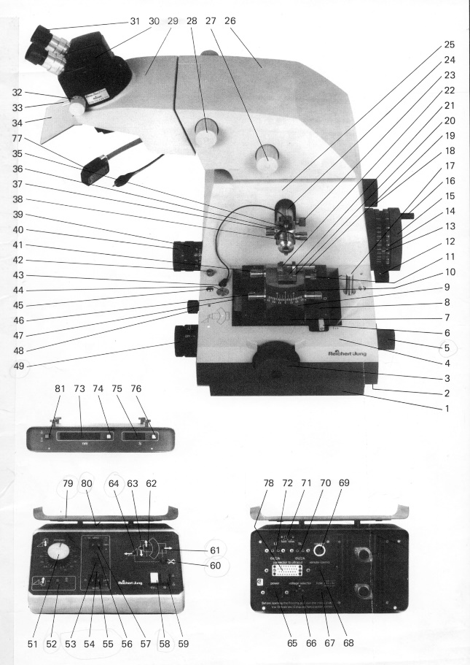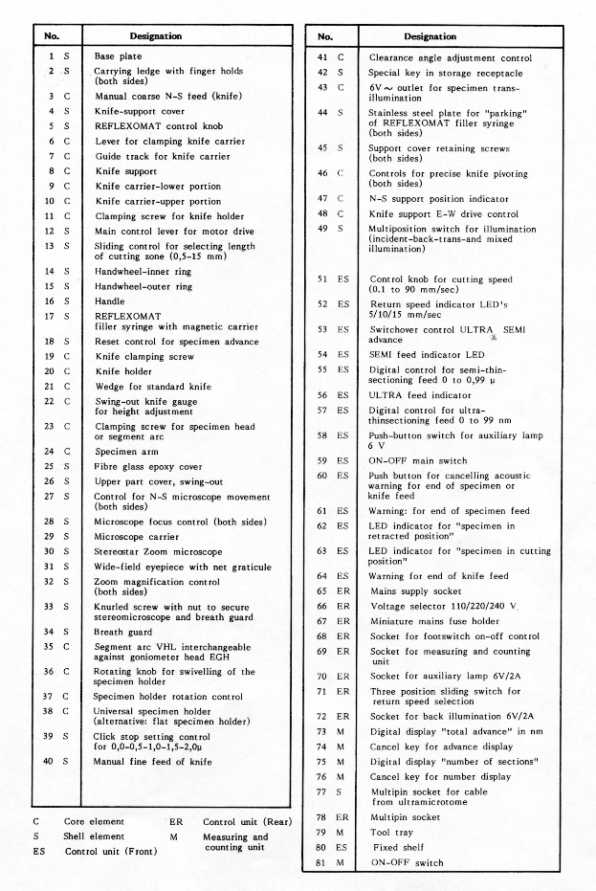
- Press main switch (59) on control unit (green signal) to light up fluorescent tubes.
- Swing stereomicroscope with carrier to the left.
- Move lever (6) on knife support to the left and take out knife carrier assembly (9/10) from its guide track (7) in an upward movement.
- Raise main control lever (12) on handwheel to its upper stop and rotate handwheel (15) slowly to its detent (arresting of inner ring).
- Preset cutting zone length with sliding control (13). Normally red dot position corresponding to 4, 5 mm.
- Fasten specimen in specimen holder (38). Insert specimen holder into segment arc VHL (35) or goniometer head EGH and secure.
- Insert segment arc into the trimming block and place trimming block with these elements in the guide (7) of knife support.
- Swing stereomicroscope over trimming block, adjust zoom to minimum magnification and shift trimming block longitudinally in the support guide (7) until the specimen appears in the center of the field of view. Then move clamping lever (6) into position “FIX”.
- Adjust zoom control (32) to red dot setting: distance between grid lines in the eyepiece graticule 1mm.
- Cut and trim specimen block with a razor blade. Cutting face is normally 0.5x1-1x2 mm². Make sure that the top and bottom of the block are parallel.
- Remove complete specimen head assembly (35) from trimming block and mount into specimen arm, segment arc normally horizontal and set to 0º position.
- Loosen lever (6) on support. Take off trimming block and replace it by knife carrier assembly (9/10) with knife.
- Slide knife carrier in its guide manually until knife is as near as possible to the specimen (approx. 1mm). Controlling this adjustment through the microscope at low magnification. Then cut clamping lever (6) into position “FIX”.
- Coarse knife-specimen alignment is made with the controls on the knife support (3, 47), the knife carrier assembly (45) and the specimen head (36).
- Fill knife boat with fresh ddH2O or 10% ethanol with pipette or syringe and adjust water level to optimum reflection.
- Fine adjustment of knife is made using the reflection in the block face. Incident light is recommended for standard glass knifes, back illumination for diamond knives (switch over the light with control 49).
- For setting the switchover point from slow cutting to fast return speed adjust the upper edge of the cutting face just below the knife edge by rotating the handwheel outer ring (15) while the main control lever is in its top position.
- Preset automatic specimen feed: ultra (57) red dot (70nm for glass and 50nm for diamond knife) and semi feed (55) to green dot (0.35º) values later for glass only.
- Set cutting speed control knob (51) on control unit at green dot (50mm/sec) for glass only.
- Put change over control (53) to SEMI (LED 54 is on).
- For automatic start of sectioning with triangular glass knife press down control lever (12) on handwheel to the lower stop. Observe the whole start of sectioning through the stereomicroscope. The left hand reminds on control knob (51) for adjusting cutting speed.
- After taking off the first section fragments reduce cutting speed without interrupting observation through the microscope. When the first full face section appears, rotate the control knob (51) on the control unit anticlockwise until it clicks in (red dot 3mm/sec) and move switch (53) from SEMI to ULTRA, LED (56) lit. Section thickness now corresponds to red dot setting of ultra feed control knob (57) (0.07º=70 nm).
- You can now expect a series of uniform ultrathin sections (generally after 3-5 sections). The sections obtained are in the gold to mat silver interference color range.
- Any further adjustment of the ultra feed control (57) can now be made.
- To remove a ribbon of sections, switch off the motor drive with lever (12) immediately after taking off a section only. Lever exactly horizontal make sure green LED (63) is lit, otherwise the continuous warning signal will start. If the red LED (62) is lit rotate handwheel (15/16) until green LED (63) is on.
- Continuation of serial sectioning after finishing off a ribbon: put main control lever (12) in its lowest position, all other controls remain unchanged.
- Picking up and staining sections
  - For ultrathin (50-90 nm) sections. The easiest way to collect is to use uncoated grids and carefully lower the grid, parallel with the surface of the boat liquid, dull side downwards, onto the sections. Or putting the grid (uncoated) under the liquid in the knife boat and then coming up under the sections with the gird. Place the grid onto a piece of filter paper with the sections facing upwards and let them dry. Stain with uranyl acetate and lead citrate.
  - For semi-thin (0.5-1 µm) sections. Transfer the section(s) with either a wire loop or mounted eyelash to a drop of water on a clean glass slide - the section should float in the drop. Place the slide on a hot plate and stain with toluidine blue-O or Azure II-methylene blue.
- Trouble shootings: knife edge wetting, block face wetting, chatter, section compression and section nicks etc.

