Updated in April 2023

Cryostat microtomes

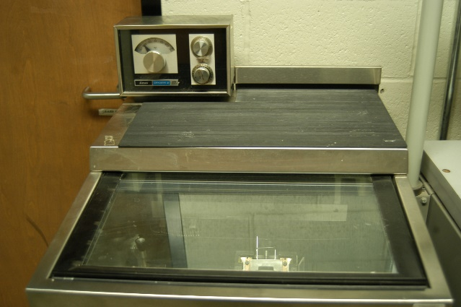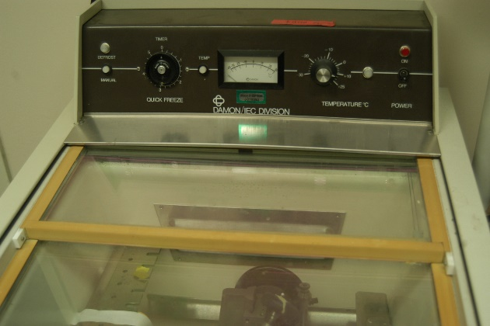
Make/Models:
- AMES 4553 (= Tissue-Tek II)
- DAMON/IEC DIVISION 3398

Features & Applications: Section thickness: 2-20 µm; Temperature range: -30º to 30º. Prepare semi-thin or thick sections for histological study.

